Experiment 1

Basic File and User Management Commands

Aim
To execute and understand the usage of rm, users, and tree commands in Kali Linux.

Theory

rm Command
The rm command is used to remove files and directories from the Linux file system.
Syntax:
rm filename
Example:
touch test.txt
rm test.txt

Users Command
Displays the usernames of users currently logged into the system.
Syntax:
users

tree Command
Displays directories and files in a tree-like structure.
Syntax:
tree

Procedure
- Open Kali Linux Terminal.
- Create a sample file.
- Execute the rm command.
- Execute the users command.
- Execute the tree command.

Sample Output
kali@kali:~$ users
kali
kali@kali:~$ tree
.
├── Documents
├── Downloads
└── Desktop

Result
Successfully executed rm, users, and tree commands in Kali Linux.
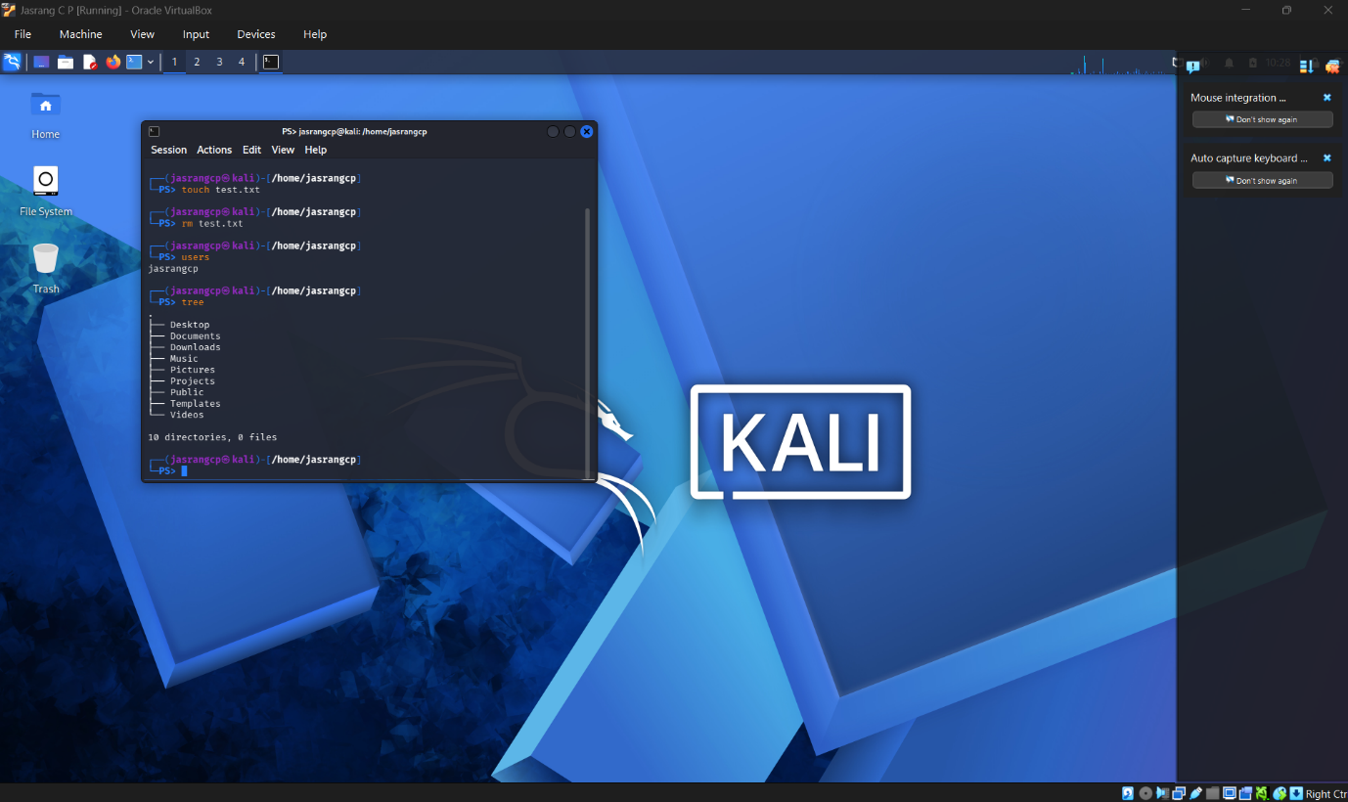

Experiment 2

File Viewing Commands

Aim
To execute and understand the usage of less, more and vi commands.

Theory

less Command
Displays file contents page by page.
less filename.txt

more Command
Displays file contents one screen at a time.
more filename.txt

vi Command
Text editor used to create and edit files.
vi filename.txt

Procedure
- Create a text file.
- Open the file using less.
- Open the file using more.
- Edit the file using vi.

Result
Successfully executed file viewing and editing commands.
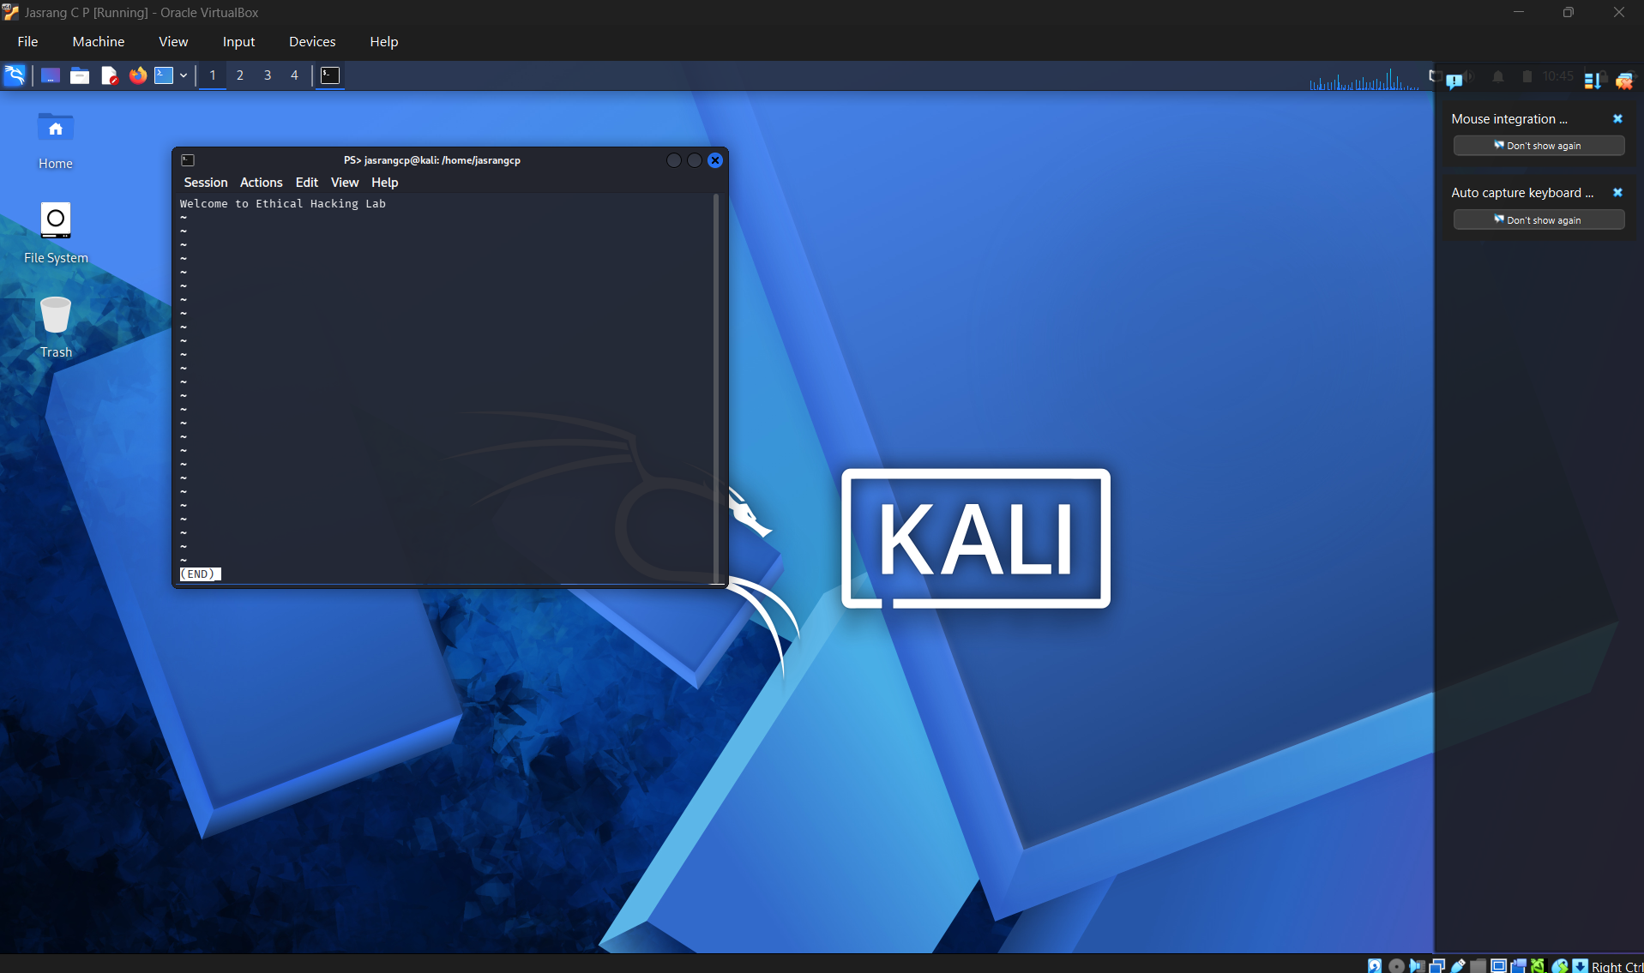

Experiment 3

Tree, Head and Tail Commands

Aim
To execute and understand the usage of tree, head, and tail commands.

Theory

head Command
Displays the first 10 lines of a file.
head filename.txt

tail Command
Displays the last 10 lines of a file.
tail filename.txt

Procedure
- Create a text file containing multiple lines.
- Execute the head command.
- Execute the tail command.
- Display directory structure using tree.

Sample Output
head student.txt
1. Arun
2. Bala
3. Kumar
tail student.txt
18. Ravi
19. Suresh
20. Priya

Result
Successfully executed tree, head, and tail commands.
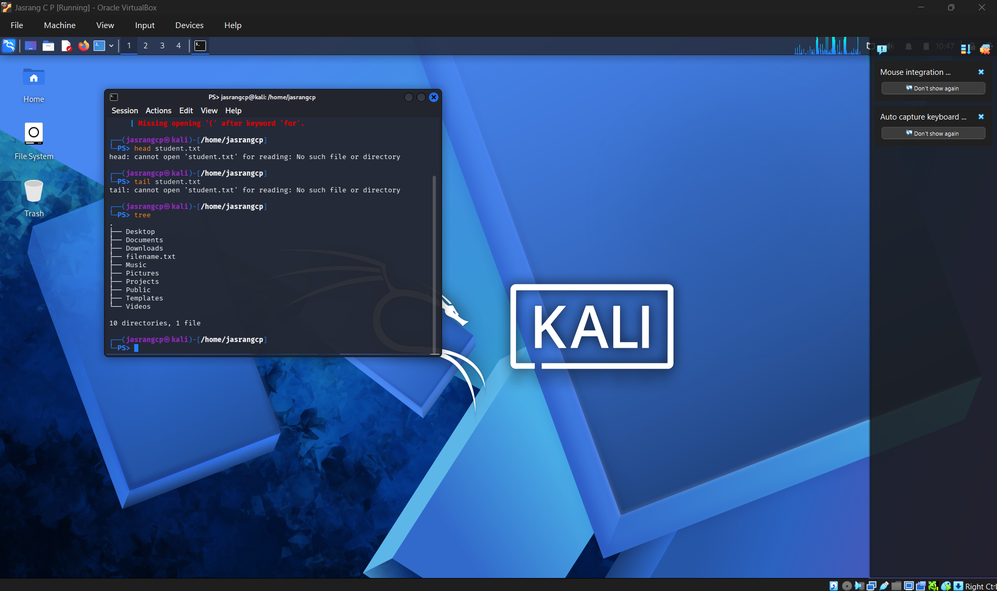

Experiment 4

Directory and File Display Commands

Aim
To execute ls, cat, and mkdir commands.

Theory

ls Command
Lists files and directories.
ls

cat Command
Displays file contents.
cat file.txt

mkdir Command
Creates a new directory.
mkdir EthicalHacking

Procedure
- Create a directory using mkdir.
- List files using ls.
- Create a text file.
- Display file contents using cat.

Result
Successfully executed ls, cat, and mkdir commands.

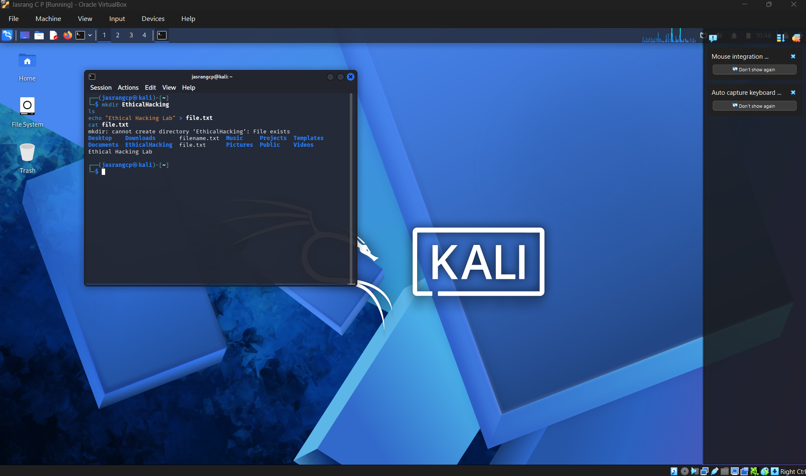

Experiment 5

System Information Commands

Aim
To execute uptime, date, and mv commands.

Theory

uptime Command
Shows system running time.
uptime

date Command
Displays current date and time.
date

mv Command
Moves or renames files.
mv file1.txt file2.txt

Procedure
- Check system uptime.
- Display current date.
- Rename a file using mv.

Result
Successfully executed uptime, date, and mv commands.

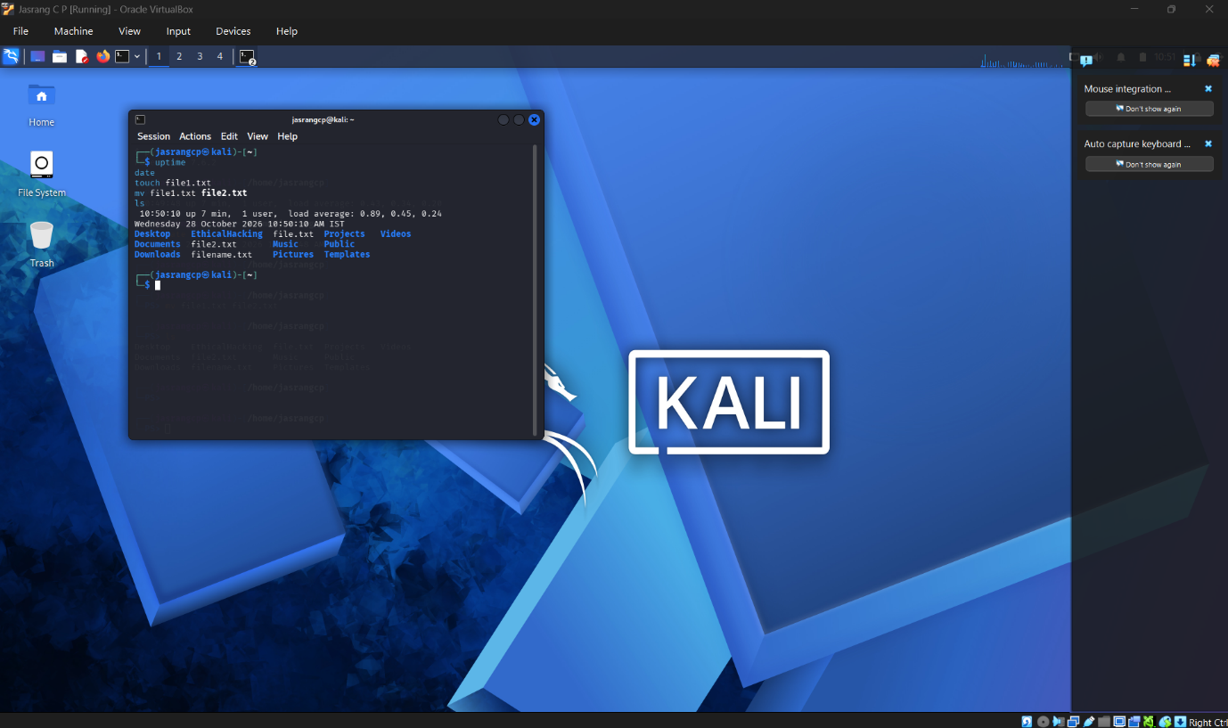

Experiment 6

File Creation and Download Commands

Aim
To execute touch, pwd, and wget commands.

Theory

touch Command
Creates an empty file.
touch sample.txt

pwd Command
Displays current working directory.
pwd

wget Command
Downloads files from the internet.
wget https://example.com/file.zip

Procedure
- Create a file using touch.
- Display current directory using pwd.
- Download a sample file using wget.

Result
Successfully executed touch, pwd, and wget commands.

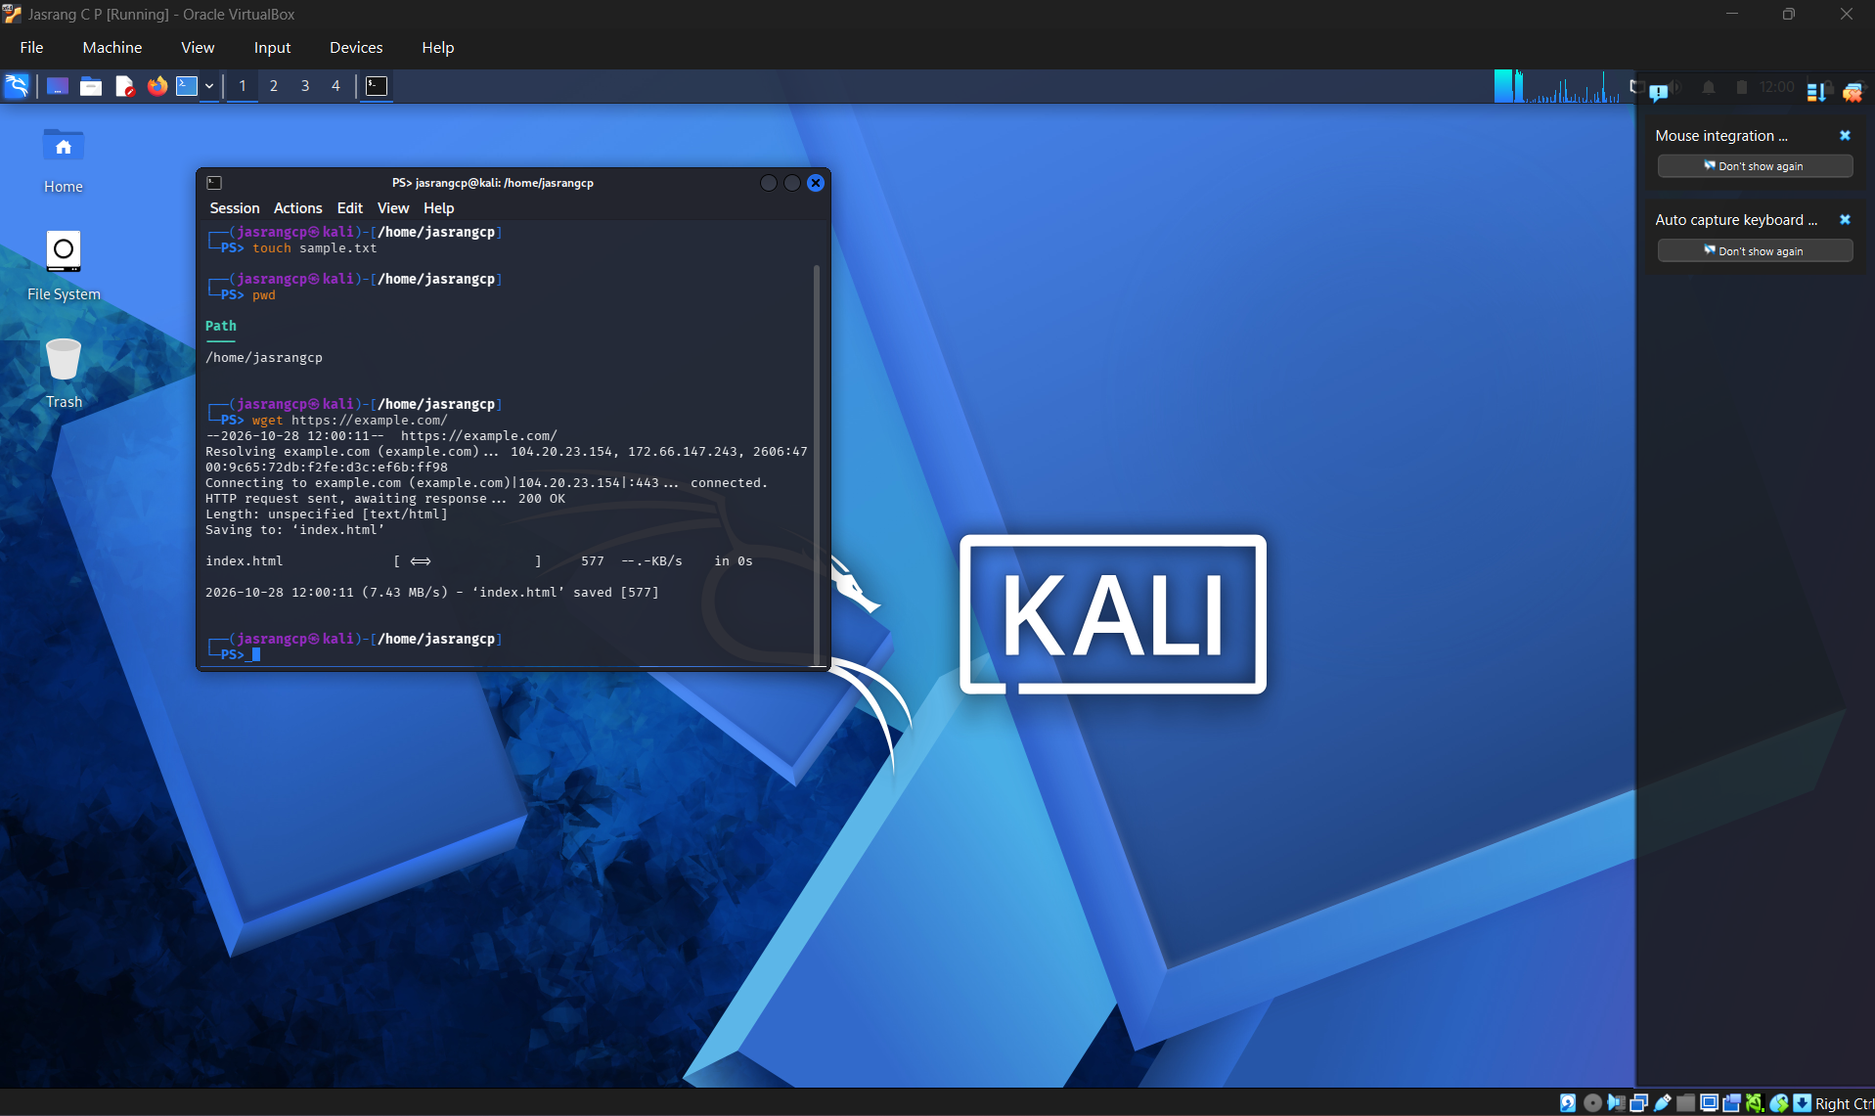

Experiment 7

Navigation and Copy Commands

Aim
To execute cd, cp, and ls commands.

Theory

cd Command
Changes the current directory.
cd Documents

cp Command
Copies files and directories.
cp file1.txt backup.txt

Procedure
- Navigate between directories using cd.
- Copy files using cp.
- Verify copied files using ls.

Result
Successfully executed cd, cp, and ls commands.
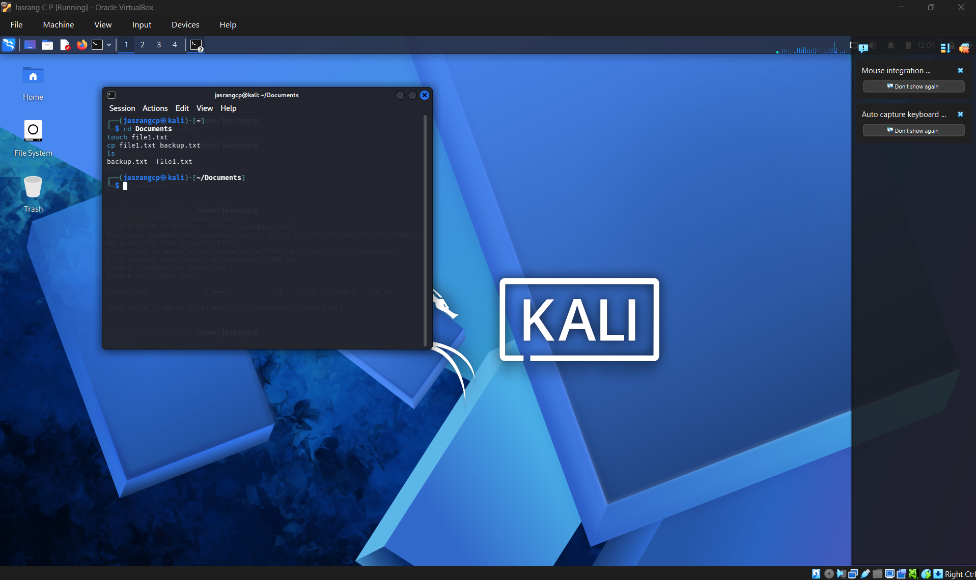

Experiment 8

Nmap Service Version and OS Detection

Aim
To perform service version detection and operating system identification using Nmap.

Theory
Nmap (Network Mapper) is an open-source network scanning tool used for network discovery and security auditing.

Commands

i) Detect Service Versions
nmap -sV 192.168.1.10
Description:
Determines the versions of services running on target ports.

ii) Aggressive Scan
nmap -A 192.168.1.10
Description:
Performs OS detection, version detection, script scanning, and traceroute.

iii) Operating System Detection
sudo nmap -O 192.168.1.10
Description:
Identifies the operating system running on the target host.

Sample Output
PORT STATE SERVICE VERSION
22/tcp open ssh OpenSSH 8.2
80/tcp open http Apache 2.4

Result
Successfully performed service version detection and OS identification using Nmap.

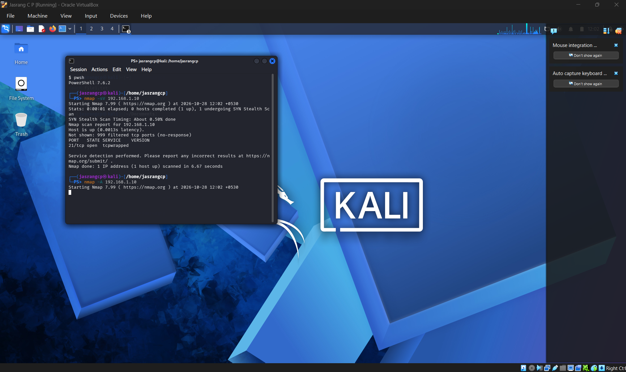

Experiment 9

Nmap Timing and Performance Commands

Aim
To perform IDS evasion and timing scans using Nmap.

Theory
Timing options control the speed and stealthiness of Nmap scans.

Commands

i) Polite IDS Evasion
nmap -T2 192.168.1.10
Description:
Slows down scanning to reduce the chance of detection.

ii) Normal Scan
nmap -T3 192.168.1.10
Description:
Default balanced scanning speed.

Procedure
- Identify target IP address.
- Execute Nmap timing commands.
- Observe scan duration and results.
- Compare scan speeds.

Result
Successfully executed Nmap timing and performance scans in Kali Linux.
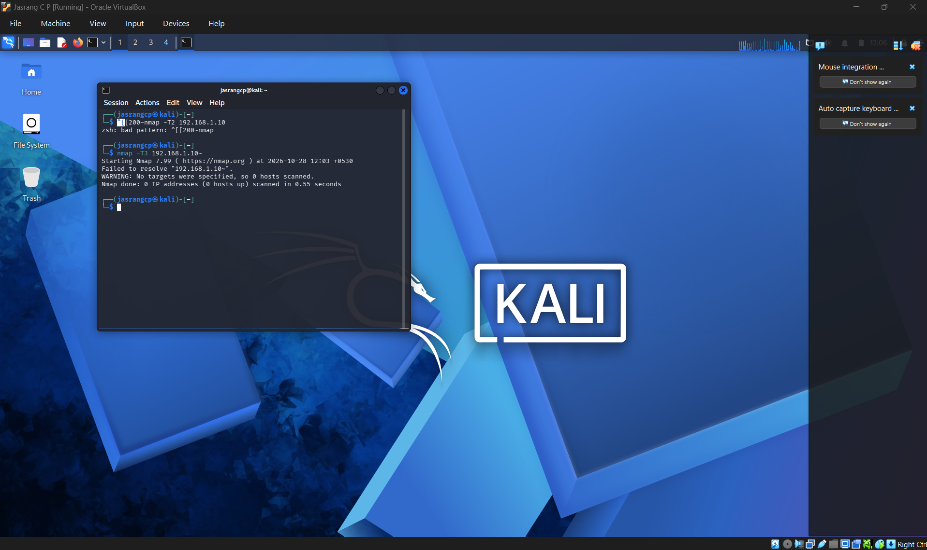

Experiment 10: Free, Sort and History Commands
Aim:
To execute and understand the usage of Free, Sort, and History commands in Kali Linux.
Commands:
free
free -h
sort file.txt
sort -r file.txt
history
history 10
Procedure:
- Open Terminal in Kali Linux.
- Execute the free command to view memory usage.
- Create a text file and use the sort command.
- Execute the history command to display previously executed commands.
Sample Output:
$ free -h
Mem: 7.6Gi 3.2Gi 2.1Gi
$ sort file.txt
Apple
Banana
Orange
$ history
1 ls
2 pwd
3 nmap localhost
Result:
Successfully executed Free, Sort, and History commands in Kali Linux.
